OSSP (Operating Systems And Systems Programming)
25CS2104E
Practical Programs – C (Linux)
1. Develop a C program that demonstrates how a Linux operating system executes a command entered by a user that 1. Accept a Linux command as input. 2. Create a child process using fork(). 3. Execute the command in the child process using an appropriate exec() system call. 4. Allow the parent process to wait for the child using wait (). 5. Display the Process ID (PID) of both parent and child processes.
#include <stdio.h>
#include <stdlib.h>
#include <unistd.h>
#include <sys/wait.h>
int main() {
char command[100];
printf("Enter command: ");
scanf("%99s", command);
pid_t pid = fork();
if (pid < 0) {
perror("fork");
return 1;
}
if (pid == 0) {
printf("Child PID: %d\n", getpid());
execlp(command, command, (char *)NULL);
perror("exec");
exit(1);
} else {
printf("Parent PID: %d\n", getpid());
printf("Waiting for child...\n");
wait(NULL);
printf("Child completed.\n");
}
return 0;
}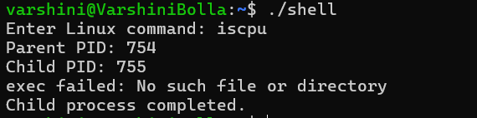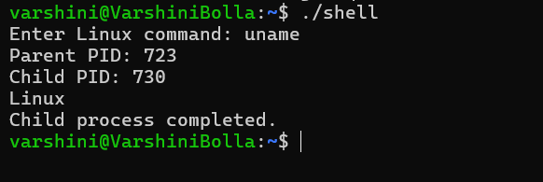
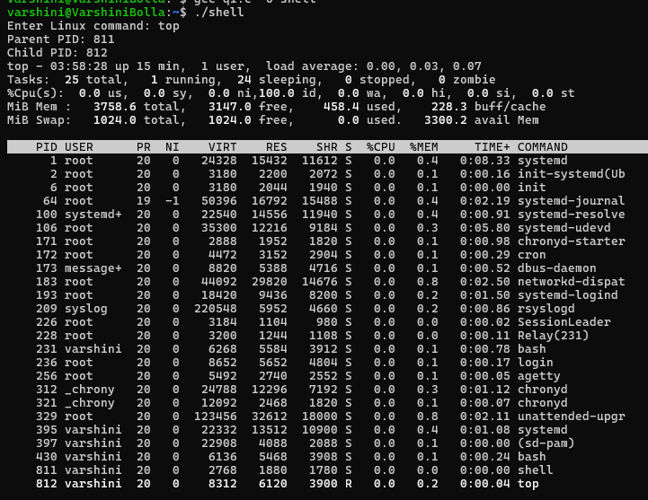
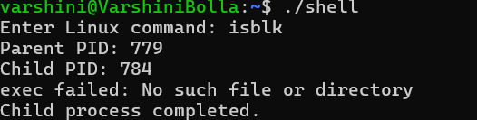
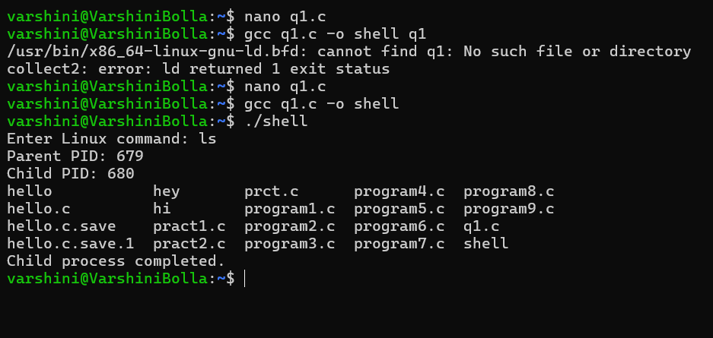

2. Develop a C program that uses the system calls open(), read(), write(), and close() to copy the contents of one file to another.
#include <stdio.h>
#include <fcntl.h>
#include <unistd.h>
int main() {
int source, destination;
char buffer[1024];
ssize_t bytes;
source = open("source.txt", O_RDONLY);
if (source < 0) {
perror("source.txt");
return 1;
}
destination = open("destination.txt",
O_WRONLY | O_CREAT | O_TRUNC, 0644);
if (destination < 0) {
perror("destination.txt");
close(source);
return 1;
}
while ((bytes = read(source, buffer, sizeof(buffer))) > 0) {
if (write(destination, buffer, bytes) != bytes) {
perror("write");
close(source);
close(destination);
return 1;
}
}
close(source);
close(destination);
printf("File copied successfully.\n");
return 0;
}
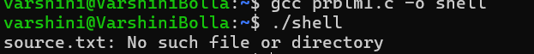

3. Develop a C program using fork() that creates a parent and child process. Display the Process ID (PID), Parent Process ID (PPID), and process states at different stages of execution.
#include <stdio.h>
#include <unistd.h>
#include <sys/wait.h>
int main() {
pid_t pid = fork();
if (pid < 0) {
perror("fork");
return 1;
}
if (pid == 0) {
printf("Child Process\n");
printf("PID : %d\n", getpid());
printf("PPID : %d\n", getppid());
printf("State: Running\n");
sleep(3);
printf("Child State: Terminated\n");
} else {
printf("Parent Process\n");
printf("PID : %d\n", getpid());
printf("PPID : %d\n", getppid());
printf("State: Running\n");
printf("Parent waiting for child...\n");
wait(NULL);
printf("Child has terminated.\n");
}
return 0;
}
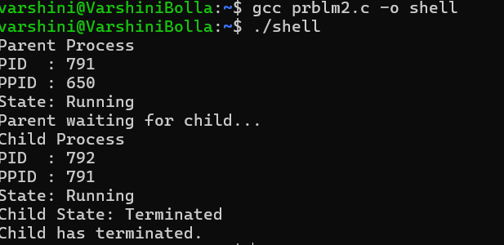

4. Write a C program where a parent process creates multiple child processes and synchronizes their completion using wait() and waitpid(). Compare the behavior of both functions.
#include <stdio.h>
#include <unistd.h>
#include <sys/wait.h>
#include <stdlib.h>
int main() {
pid_t children[3];
for (int i = 0; i < 3; i++) {
children[i] = fork();
if (children[i] < 0) {
perror("fork");
return 1;
}
if (children[i] == 0) {
printf("Child %d: PID = %d\n", i + 1, getpid());
sleep(i + 1);
printf("Child %d completed.\n", i + 1);
exit(0);
}
}
printf("\nUsing wait():\n");
wait(NULL);
printf("One child completed using wait().\n");
printf("\nUsing waitpid():\n");
for (int i = 0; i < 3; i++) {
waitpid(children[i], NULL, 0);
printf("Child PID %d completed using waitpid().\n", children[i]);
}
return 0;
}
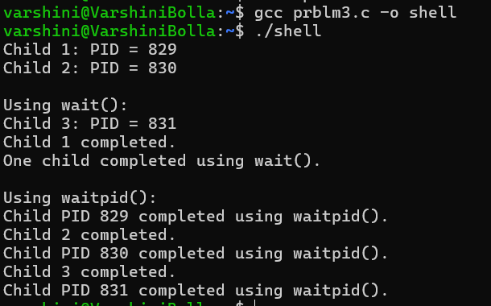

5. Implement a producer-consumer communication system using anonymous pipes where the parent process generates data and the child process consumes it.
#include <stdio.h>
#include <unistd.h>
#include <string.h>
int main() {
int pipefd[2];
pid_t pid;
char message[] = "Data produced by parent process";
char buffer[100];
if (pipe(pipefd) == -1) {
perror("pipe");
return 1;
}
pid = fork();
if (pid < 0) {
perror("fork");
return 1;
}
if (pid > 0) {
close(pipefd[0]);
write(pipefd[1], message, strlen(message) + 1);
printf("Producer: Data sent.\n");
close(pipefd[1]);
} else {
close(pipefd[1]);
read(pipefd[0], buffer, sizeof(buffer));
printf("Consumer: %s\n", buffer);
close(pipefd[0]);
}
return 0;
}
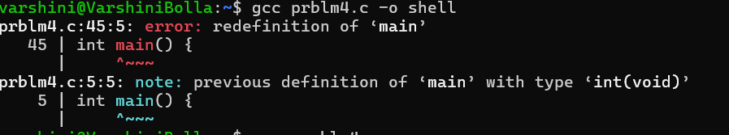

5(b). Develop a program that executes the equivalent of the shell command: ls -l | grep ".c" using fork(), pipe(), dup2(), and exec() system calls.
#include <stdio.h>
#include <unistd.h>
#include <sys/wait.h>
int main() {
int pipefd[2];
pid_t p1, p2;
pipe(pipefd);
p1 = fork();
if (p1 == 0) {
close(pipefd[0]);
dup2(pipefd[1], STDOUT_FILENO);
close(pipefd[1]);
execlp("ls", "ls", "-l", (char *)NULL);
perror("ls");
return 1;
}
p2 = fork();
if (p2 == 0) {
close(pipefd[1]);
dup2(pipefd[0], STDIN_FILENO);
close(pipefd[0]);
execlp("grep", "grep", ".c", (char *)NULL);
perror("grep");
return 1;
}
close(pipefd[0]);
close(pipefd[1]);
waitpid(p1, NULL, 0);
waitpid(p2, NULL, 0);
return 0;
}
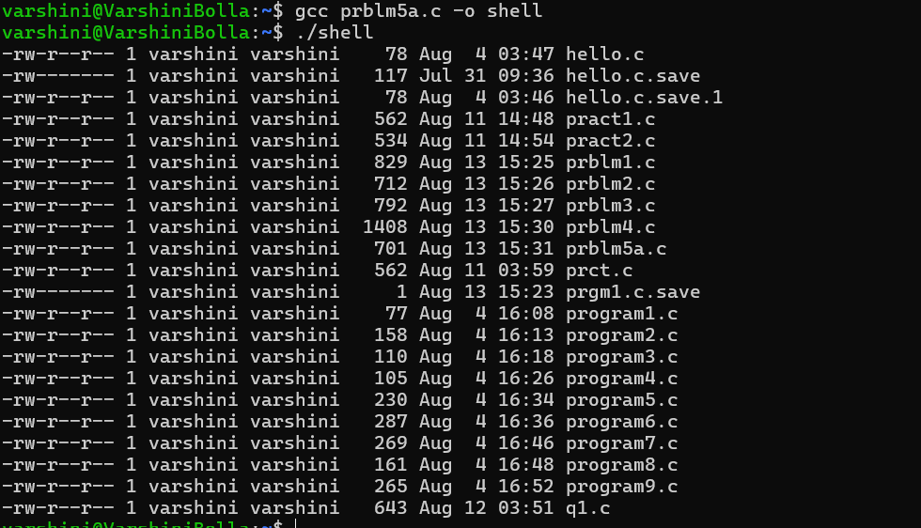

6. Create a client-server application using Named Pipes (FIFOs). The client sends messages and the server processes and responds to them.
/* server.c */
#include <stdio.h>
#include <fcntl.h>
#include <unistd.h>
#include <sys/stat.h>
#include <string.h>
int main() {
int fd;
char buffer[100];
mkfifo("client_fifo", 0666);
mkfifo("server_fifo", 0666);
printf("Server waiting...\n");
fd = open("client_fifo", O_RDONLY);
read(fd, buffer, sizeof(buffer));
close(fd);
printf("Client: %s\n", buffer);
fd = open("server_fifo", O_WRONLY);
char response[] = "Message received by server.";
write(fd, response, strlen(response) + 1);
close(fd);
return 0;
}
/* client.c
Compile separately as: gcc client.c -o client
*/
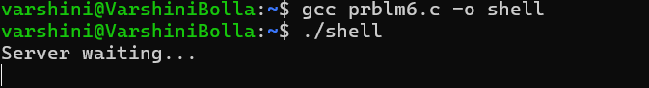

6(b). Create a POSIX signal handling program that captures SIGINT, SIGTERM, and SIGUSR1.
#include <stdio.h>
#include <signal.h>
#include <unistd.h>
void handler(int signal) {
if (signal == SIGINT)
printf("\nSIGINT received.\n");
else if (signal == SIGTERM)
printf("\nSIGTERM received.\n");
else if (signal == SIGUSR1)
printf("\nSIGUSR1 received.\n");
}
int main() {
signal(SIGINT, handler);
signal(SIGTERM, handler);
signal(SIGUSR1, handler);
printf("PID: %d\n", getpid());
printf("Waiting for signals...\n");
while (1) {
pause();
}
return 0;
}
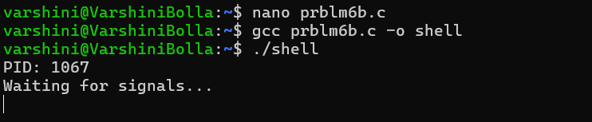

7. Write a program that prints the addresses of code, global, static, heap, and stack variables.
#include <stdio.h>
#include <stdlib.h>
int global_var = 10;
void code_function() {
}
int main() {
static int static_var = 20;
int stack_var = 30;
int *heap_var = malloc(sizeof(int));
if (heap_var == NULL)
return 1;
*heap_var = 40;
printf("Code address : %p\n", (void *)code_function);
printf("Global address : %p\n", (void *)&global_var);
printf("Static address : %p\n", (void *)&static_var);
printf("Heap address : %p\n", (void *)heap_var);
printf("Stack address : %p\n", (void *)&stack_var);
free(heap_var);
return 0;
}
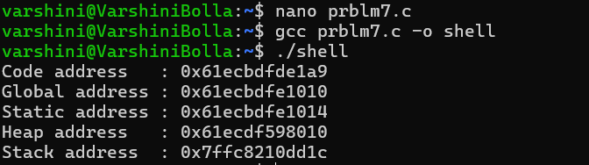

8. Develop a program using malloc(), calloc(), realloc(), and free().
#include <stdio.h>
#include <stdlib.h>
int main() {
int *ptr;
ptr = malloc(3 * sizeof(int));
if (ptr == NULL)
return 1;
for (int i = 0; i < 3; i++)
ptr[i] = i + 1;
printf("malloc: ");
for (int i = 0; i < 3; i++)
printf("%d ", ptr[i]);
ptr = realloc(ptr, 5 * sizeof(int));
if (ptr == NULL)
return 1;
ptr[3] = 4;
ptr[4] = 5;
printf("\nrealloc: ");
for (int i = 0; i < 5; i++)
printf("%d ", ptr[i]);
free(ptr);
ptr = calloc(5, sizeof(int));
if (ptr == NULL)
return 1;
printf("\ncalloc: ");
for (int i = 0; i < 5; i++)
printf("%d ", ptr[i]);
free(ptr);
printf("\nMemory released successfully.\n");
return 0;
}
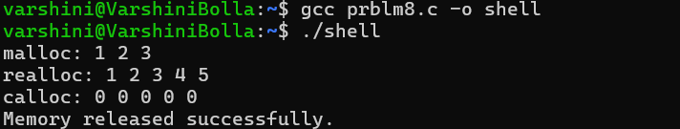

8(b). Develop a program that demonstrates Copy-on-Write behavior after a fork().
#include <stdio.h>
#include <stdlib.h>
#include <unistd.h>
#include <sys/wait.h>
int main() {
int *data = malloc(sizeof(int));
*data = 100;
pid_t pid = fork();
if (pid < 0) {
perror("fork");
free(data);
return 1;
}
if (pid == 0) {
printf("Child before modification: %d\n", *data);
*data = 200;
printf("Child after modification : %d\n", *data);
} else {
sleep(1);
printf("Parent value: %d\n", *data);
wait(NULL);
}
free(data);
return 0;
}
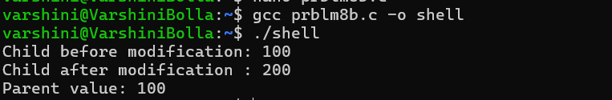

9. Implement a file copy utility using low-level Linux file I/O system calls (open, read, write, lseek, close).
#include <stdio.h>
#include <fcntl.h>
#include <unistd.h>
int main() {
int source, destination;
char buffer[1024];
ssize_t bytes;
source = open("source.txt", O_RDONLY);
destination = open("destination.txt",
O_WRONLY | O_CREAT | O_TRUNC, 0644);
if (source < 0 || destination < 0) {
perror("open");
return 1;
}
while ((bytes = read(source, buffer, sizeof(buffer))) > 0) {
write(destination, buffer, bytes);
}
lseek(source, 0, SEEK_SET);
close(source);
close(destination);
printf("File copied using low-level I/O.\n");
return 0;
}
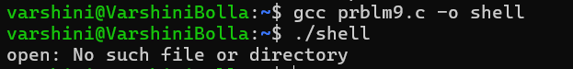
9(b). Develop a program that redirects standard input and output using file descriptors and dup2().
#include <stdio.h>
#include <fcntl.h>
#include <unistd.h>
int main() {
int input, output;
input = open("input.txt", O_RDONLY);
output = open("output.txt", O_WRONLY | O_CREAT | O_TRUNC, 0644);
if (input < 0 || output < 0) {
perror("open");
return 1;
}
dup2(input, STDIN_FILENO);
dup2(output, STDOUT_FILENO);
close(input);
close(output);
printf("This output is redirected to output.txt\n");
return 0;
}
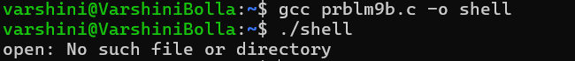
10. Investigate inode structures using commands such as ls -i, stat, and find. Create hard links and symbolic links and explain their impact on inode allocation.
#include <stdio.h>
#include <unistd.h>
int main() {
FILE *fp;
fp = fopen("original.txt", "w");
if (fp == NULL)
return 1;
fprintf(fp, "This is the original file.\n");
fclose(fp);
link("original.txt", "hardlink.txt");
symlink("original.txt", "softlink.txt");
printf("Files created successfully.\n");
printf("Use these commands to inspect them:\n");
printf("ls -li original.txt hardlink.txt softlink.txt\n");
printf("stat original.txt\n");
printf("find . -inum <inode_number>\n");
return 0;
}
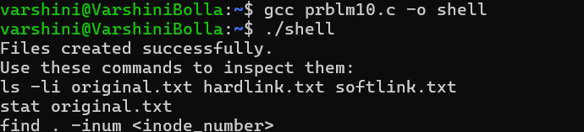

10(b). Design a program using mmap() to perform file reading and writing.
#include <stdio.h>
#include <fcntl.h>
#include <unistd.h>
#include <sys/mman.h>
#include <string.h>
#include <sys/stat.h>
int main() {
int fd;
const char *text = "Hello using mmap!";
size_t size = strlen(text) + 1;
fd = open("mmapfile.txt", O_RDWR | O_CREAT, 0644);
if (fd < 0) {
perror("open");
return 1;
}
ftruncate(fd, size);
char *data = mmap(NULL, size,
PROT_READ | PROT_WRITE,
MAP_SHARED, fd, 0);
if (data == MAP_FAILED) {
perror("mmap");
close(fd);
return 1;
}
strcpy(data, text);
printf("File content: %s\n", data);
msync(data, size, MS_SYNC);
munmap(data, size);
close(fd);
return 0;
}
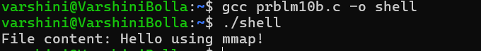

11. Develop a multithreaded counter application using POSIX threads (pthread_create, pthread_join). Demonstrate race conditions by allowing multiple threads to update a shared variable concurrently.
#include <stdio.h>
#include <pthread.h>
int counter = 0;
void *increment(void *arg) {
for (int i = 0; i < 100000; i++)
counter++;
return NULL;
}
int main() {
pthread_t t1, t2;
pthread_create(&t1, NULL, increment, NULL);
pthread_create(&t2, NULL, increment, NULL);
pthread_join(t1, NULL);
pthread_join(t2, NULL);
printf("Final counter value: %d\n", counter);
return 0;
}
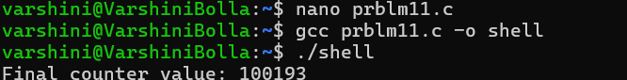

11(b). Modify the previous program using mutex locks (pthread_mutex_lock, pthread_mutex_unlock) and compare the outputs with the race-condition version.
#include <stdio.h>
#include <pthread.h>
int counter = 0;
pthread_mutex_t lock;
void *increment(void *arg) {
for (int i = 0; i < 100000; i++) {
pthread_mutex_lock(&lock);
counter++;
pthread_mutex_unlock(&lock);
}
return NULL;
}
int main() {
pthread_t t1, t2;
pthread_mutex_init(&lock, NULL);
pthread_create(&t1, NULL, increment, NULL);
pthread_create(&t2, NULL, increment, NULL);
pthread_join(t1, NULL);
pthread_join(t2, NULL);
printf("Final counter value: %d\n", counter);
pthread_mutex_destroy(&lock);
return 0;
}

12. Implement the Producer-Consumer problem using counting semaphores and POSIX threads.
#include <stdio.h>
#include <pthread.h>
#include <semaphore.h>
#include <unistd.h>
#define SIZE 5
int buffer[SIZE];
int in = 0, out = 0;
sem_t empty, full;
pthread_mutex_t mutex;
void *producer(void *arg) {
for (int i = 1; i <= 10; i++) {
sem_wait(&empty);
pthread_mutex_lock(&mutex);
buffer[in] = i;
printf("Produced: %d\n", i);
in = (in + 1) % SIZE;
pthread_mutex_unlock(&mutex);
sem_post(&full);
sleep(1);
}
return NULL;
}
void *consumer(void *arg) {
for (int i = 1; i <= 10; i++) {
sem_wait(&full);
pthread_mutex_lock(&mutex);
int item = buffer[out];
printf("Consumed: %d\n", item);
out = (out + 1) % SIZE;
pthread_mutex_unlock(&mutex);
sem_post(&empty);
sleep(1);
}
return NULL;
}
int main() {
pthread_t p, c;
sem_init(&empty, 0, SIZE);
sem_init(&full, 0, 0);
pthread_mutex_init(&mutex, NULL);
pthread_create(&p, NULL, producer, NULL);
pthread_create(&c, NULL, consumer, NULL);
pthread_join(p, NULL);
pthread_join(c, NULL);
sem_destroy(&empty);
sem_destroy(&full);
pthread_mutex_destroy(&mutex);
return 0;
}
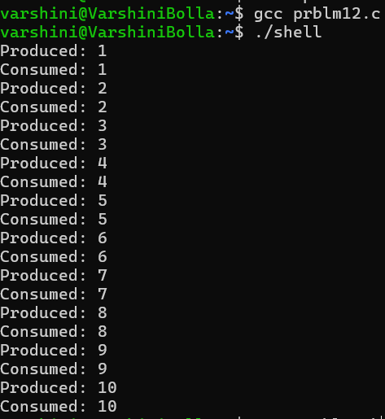

12(b). Design a deadlock scenario involving multiple threads competing for shared resources. Demonstrate deadlock occurrence and implement a deadlock prevention strategy using resource ordering.
/* Deadlock prevention using resource ordering */
#include <stdio.h>
#include <pthread.h>
#include <unistd.h>
pthread_mutex_t resource1 = PTHREAD_MUTEX_INITIALIZER;
pthread_mutex_t resource2 = PTHREAD_MUTEX_INITIALIZER;
void *thread1(void *arg) {
pthread_mutex_lock(&resource1);
printf("Thread 1 locked Resource 1\n");
sleep(1);
pthread_mutex_lock(&resource2);
printf("Thread 1 locked Resource 2\n");
pthread_mutex_unlock(&resource2);
pthread_mutex_unlock(&resource1);
return NULL;
}
void *thread2(void *arg) {
/* Same order: Resource 1 first, then Resource 2 */
pthread_mutex_lock(&resource1);
printf("Thread 2 locked Resource 1\n");
sleep(1);
pthread_mutex_lock(&resource2);
printf("Thread 2 locked Resource 2\n");
pthread_mutex_unlock(&resource2);
pthread_mutex_unlock(&resource1);
return NULL;
}
int main() {
pthread_t t1, t2;
pthread_create(&t1, NULL, thread1, NULL);
pthread_create(&t2, NULL, thread2, NULL);
pthread_join(t1, NULL);
pthread_join(t2, NULL);
printf("No deadlock occurred because resources are locked in the same order.\n");
return 0;
}
